

HTML Assignment 1

FSE HTML Assignment



November 12, 2018

Cognizant

Kolkata

Contents

**NAVIGATION PAGE:** 1

**INDEX PAGE:** 2

**PROFILE HIGHLIGHTS:** 2

**PROJECTS:** 4

**EXPERIENCE:** 5

**PERSONAL BIOGRAPHY:** 6

**CONTACT ME:** 8

# **NAVIGATION PAGE:**

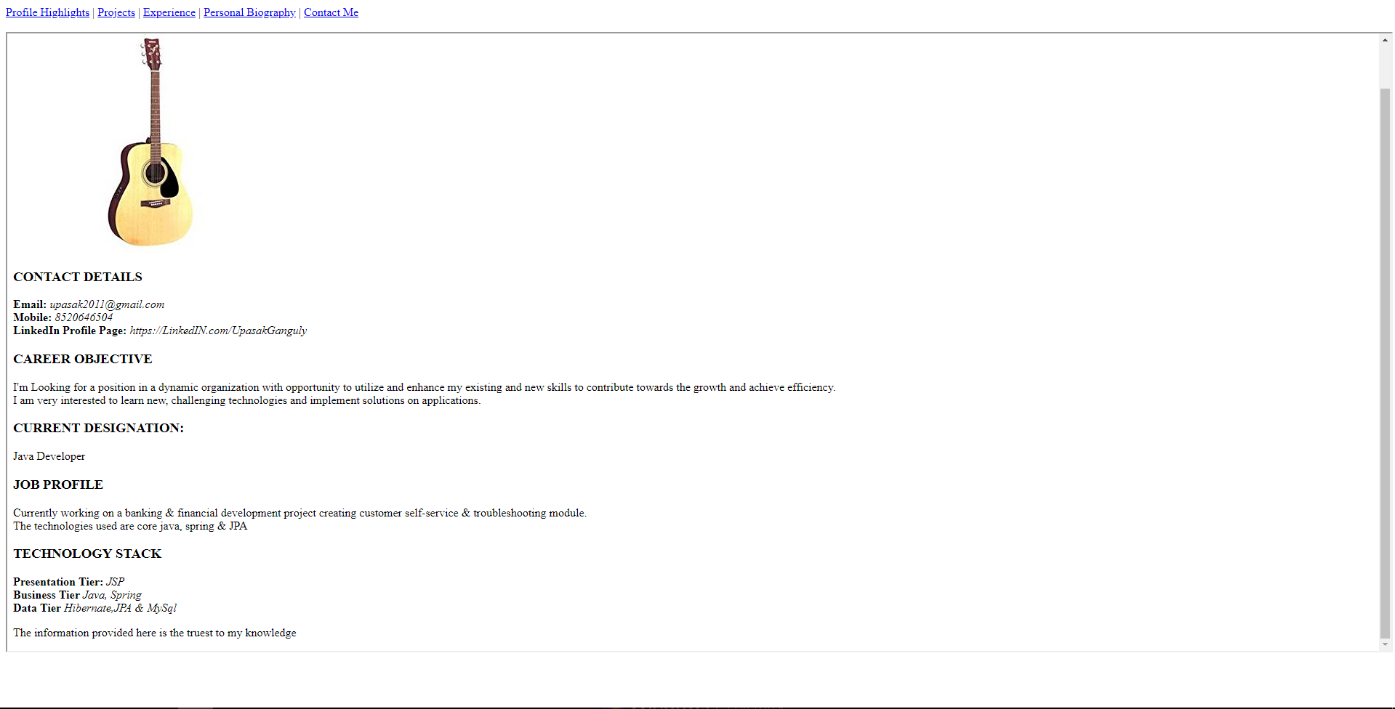



# **INDEX PAGE:**

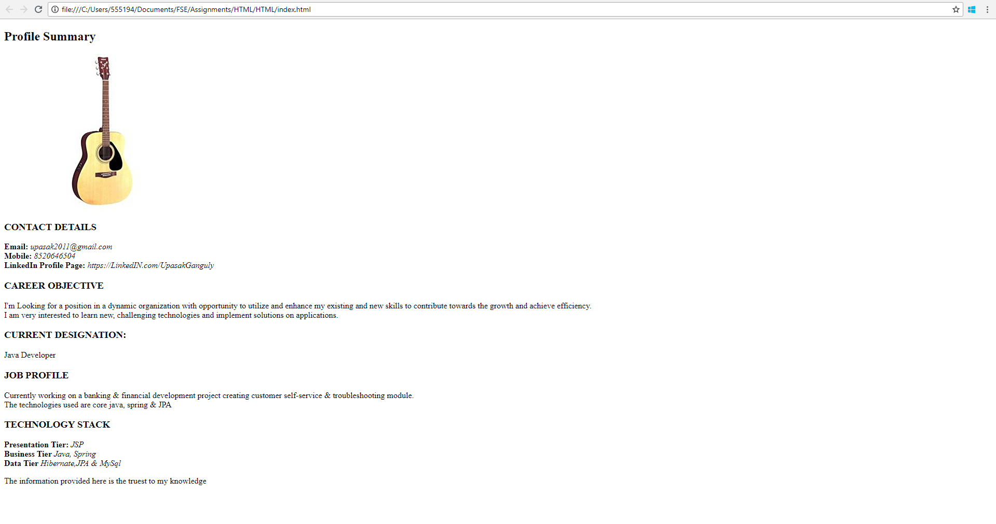



# **PROFILE HIGHLIGHTS:**

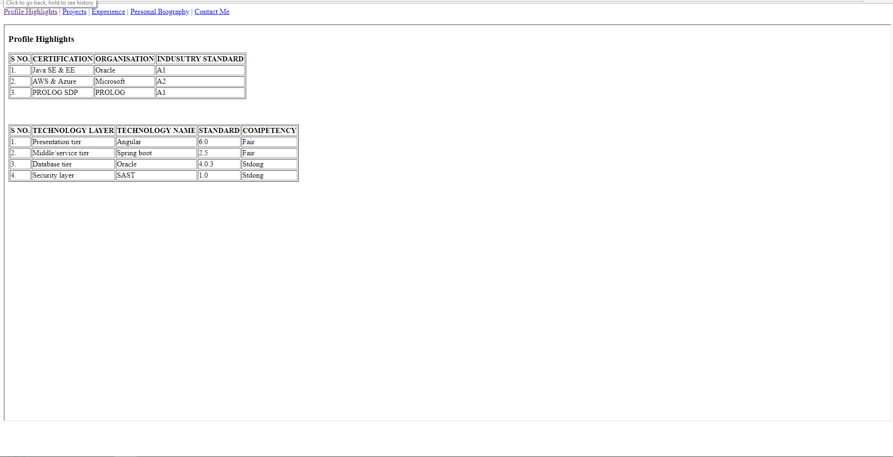

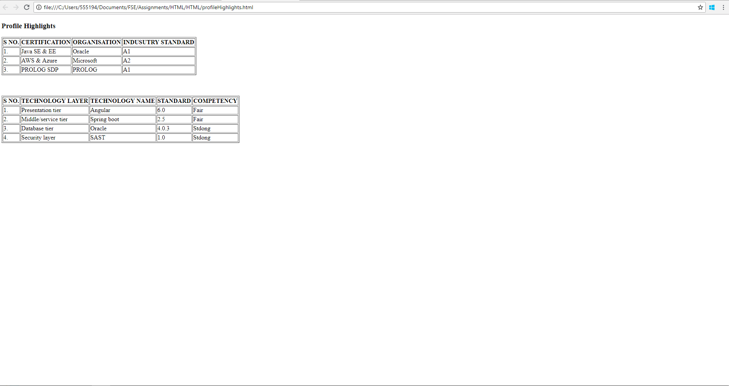



# **PROJECTS:**

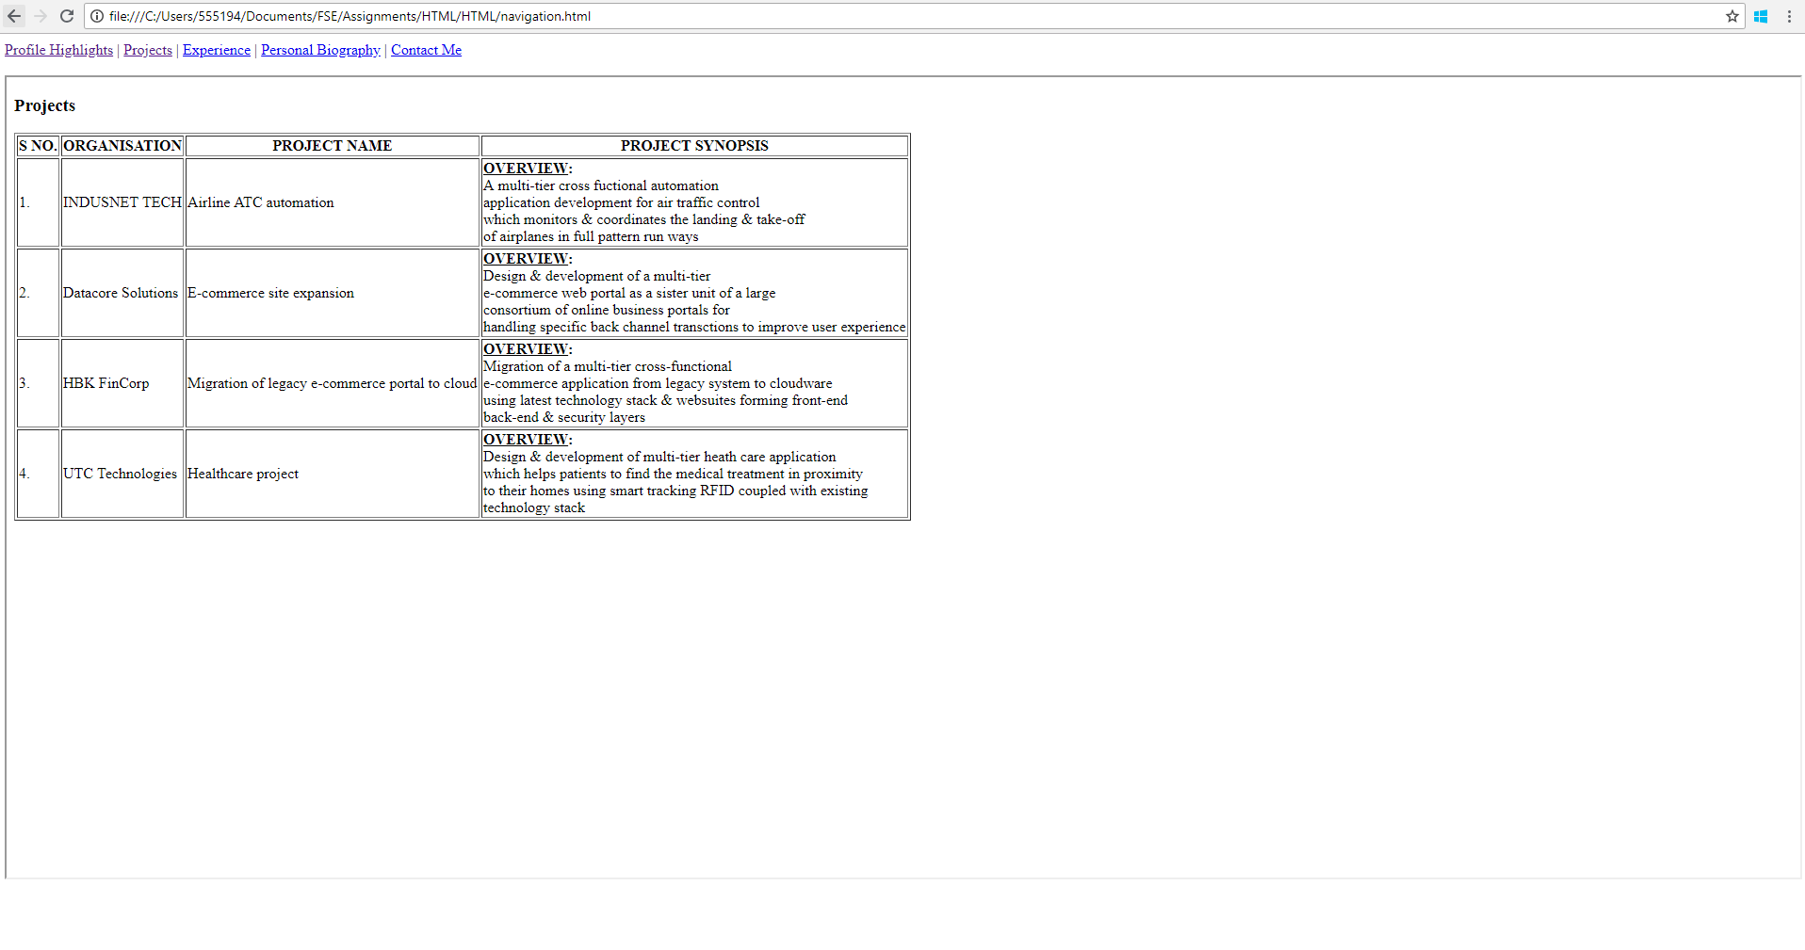

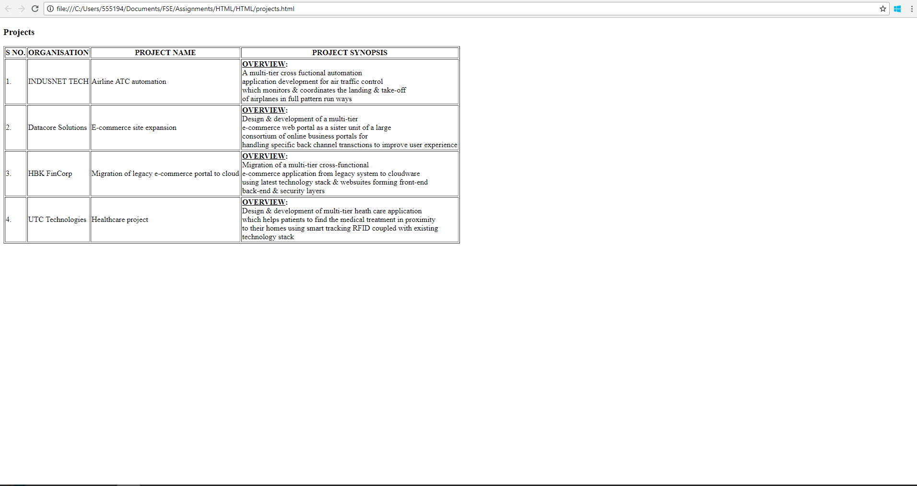



# **EXPERIENCE:**

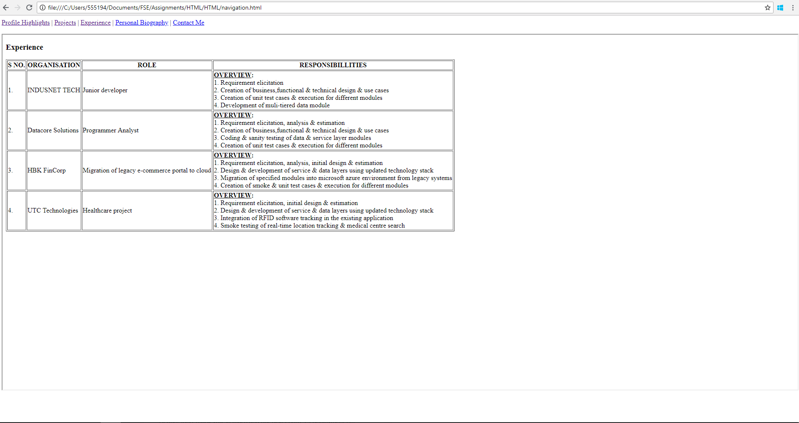

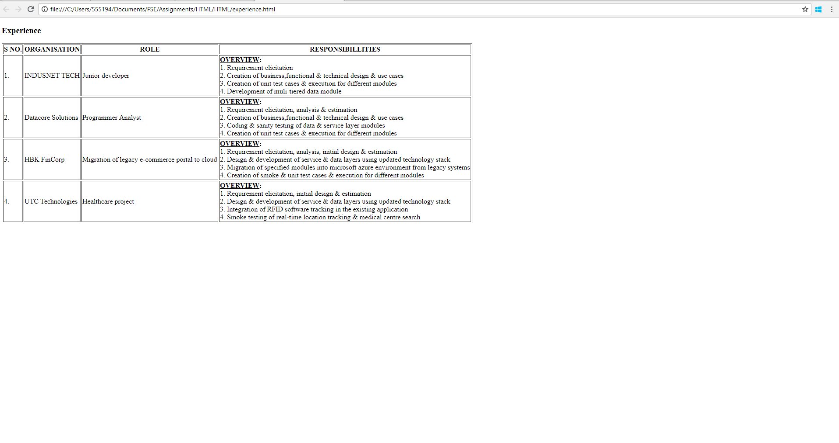



# **PERSONAL BIOGRAPHY:**

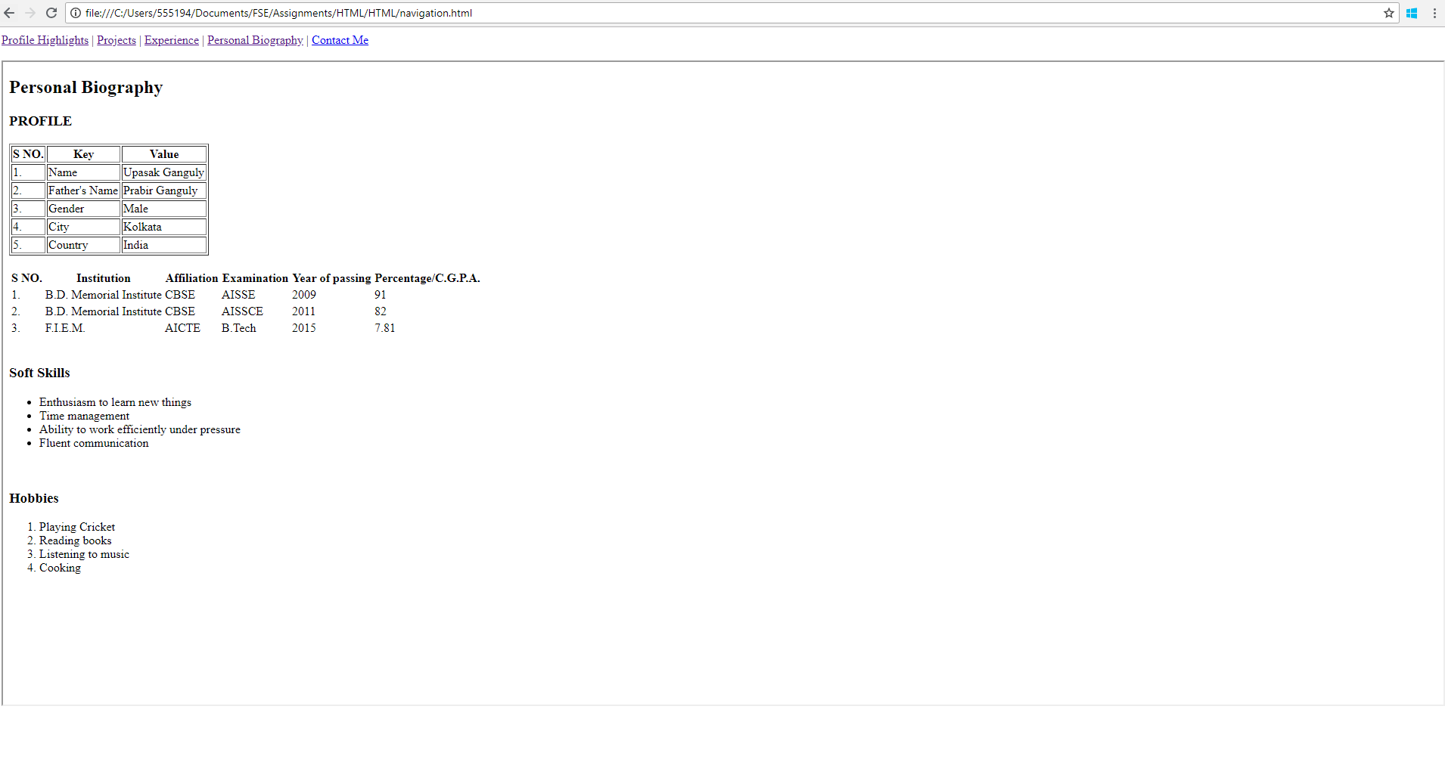

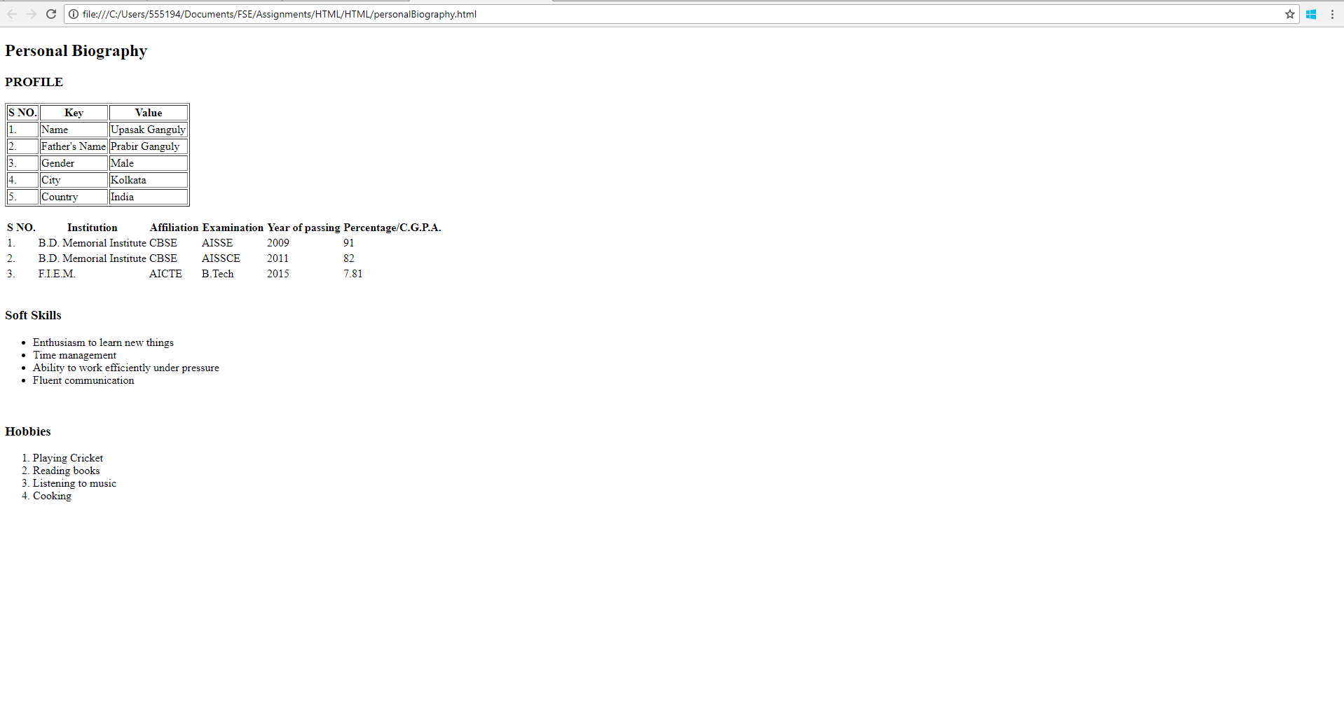



# **CONTACT ME:**

